Lab: Data Access in DSX

January 10th, 2018

Author: Elena Lowery elowery@us.ibm.com
Table of contents
Contents
Overview 1
Required software, access, and files 1
Part 1: Set up a database 1
Part 2: Configure database connection in DSX 4
Part 3: Test Database Connection 6
Part 4: Configure HDFS and Hive connections in DSX 7
Part 5 : Test HDFS and Hive connection 13

Overview
In this lab you will learn how to access database and Hortonworks Data Platform (HDP) data sources in DSX. You will learn how to
- Define a database connection for a database that’s supported via UI
- Connect to a database data source which is not supported in the UI
- Connect to a non-secure HDP cluster

Required software, access, and files
• To complete this lab, you will need access to a DSX Local cluster and HDP.
• You will also need to download and unzip this GitHub repository: https://github.com/elenalowery/DSX_Local_Workshop

Part 1: Set up a database

In this section we will set up a database in IBM Cloud so that we can test database access from DSX. If you already have an external database that you would like to use, you can skip this section.

At this time the names dashDB and DB2 on Cloud are used interchangeably.

Note: If you are not able to create the DB2 on Cloud service, please ask the lab instructor for a pre-configured instance.

- Create a DB2 on Cloud service in IBM Cloud

- Login to Bluemix: bluemix.net
- Search for “db2 on cloud” and create the service

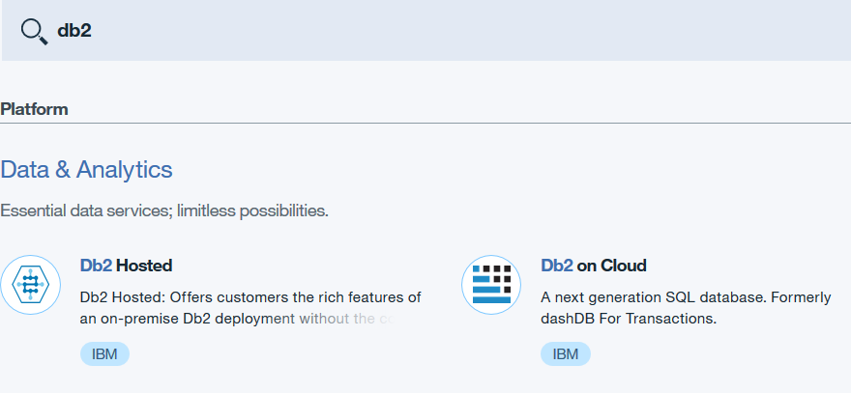

- Lookup service credentials in Bluemix and save them in a notepad

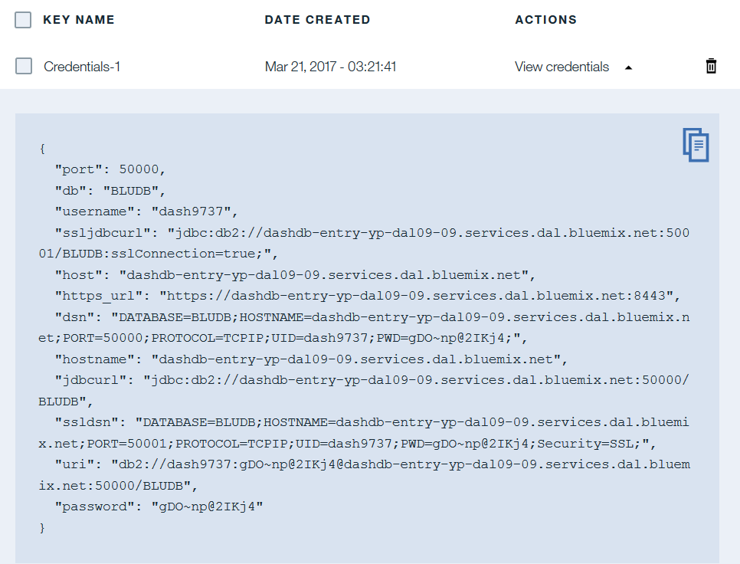

4. Click Open to open the dashDB console

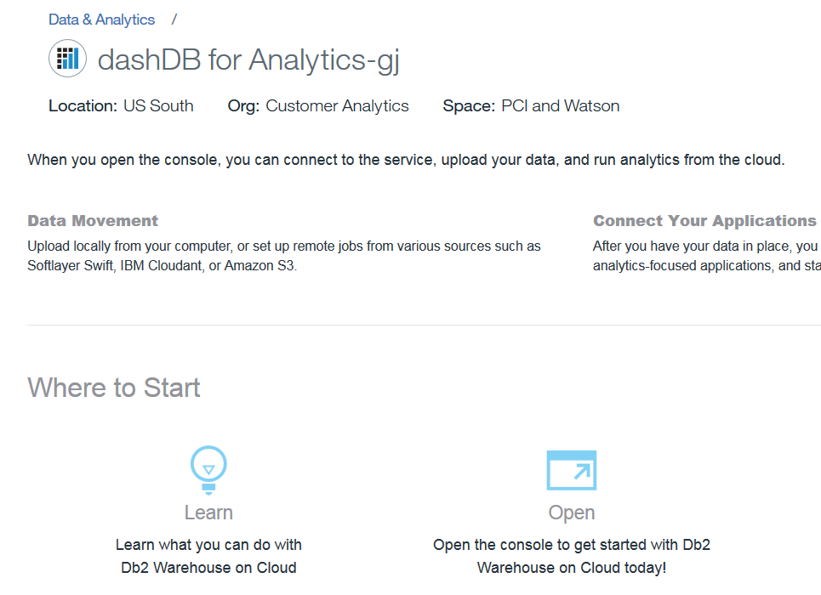

- Click Load

- Click Load Data

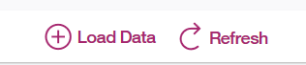

- Select browse files and navigate to the data folder of the unzipped GitHub repository. Select customer.csv. Click Next.

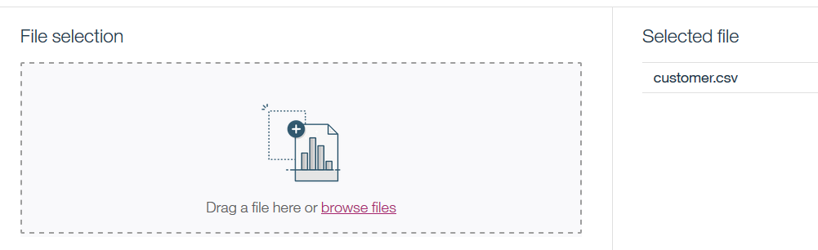

- Select Schema (which will be different than the screenshot in your instance) and click New Table. Enter table name CUSTOMER and click Create. Click Next.

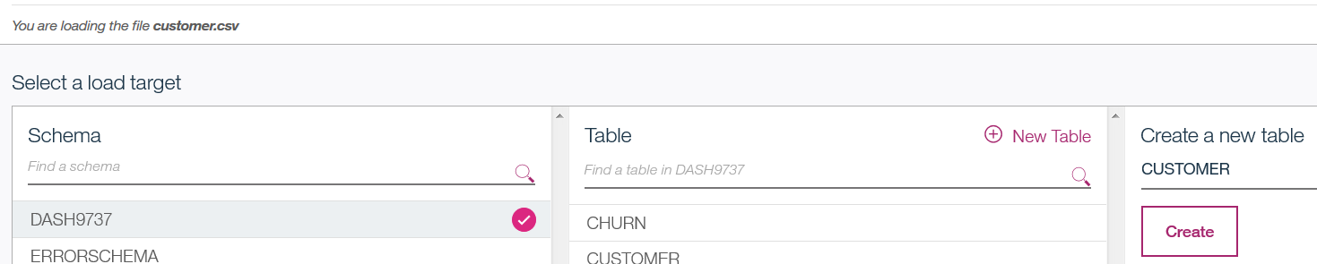

- Leave the default values on the Define Table screen. Click Next. Then Begin Load.

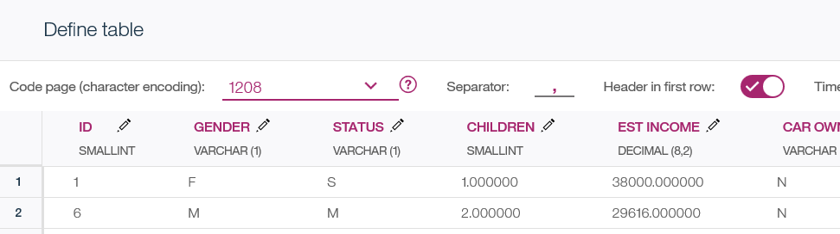
- If you want to verify that data has been loaded successfully, click View Table.

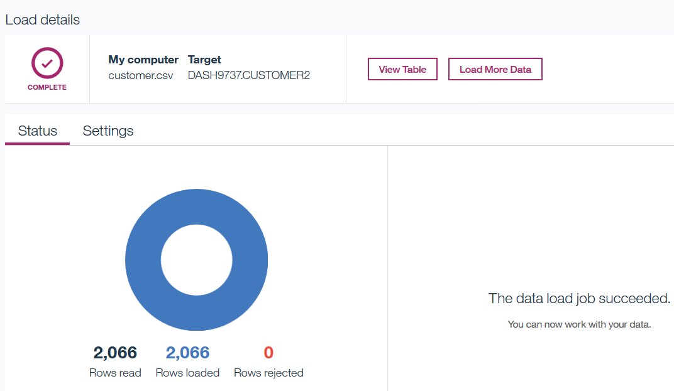

- If you want to convert all sample notebooks to the database data sources, then repeat the data load steps for all files in the /data directory.

Part 2: Configure database connection in DSX
In this section we will define a connection in the DSX UI and test it in a notebook.

- Open a DSX Local project (for example, DSX_Local_Workshop) or create a new DSX Local project.

- Click on Data Sources, then add data source

- Enter data source name (for example, dashDB_DS) and fill out the required fields (which you saved from Service Credentials view in IBM Cloud).

Do not check the “Shared” checkbox. If you select it, then your credentials will be shared with collaborators on the project.

Click Create.

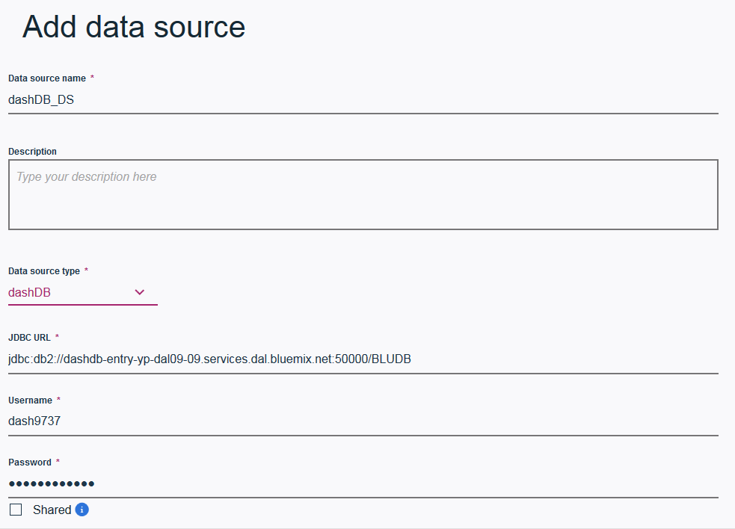

- Switch to the Assets view and scroll down to Data Sets. Click add data set. Select the created data source from the dropdown and enter the required fields.

In our example we gave the same name to the data set as the table name – CUSTOMER. Your schema name will be different.

Click Save.

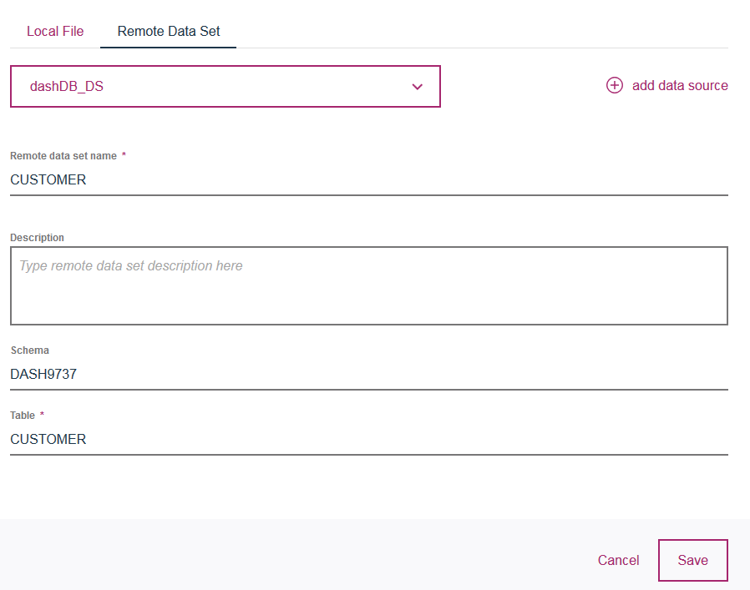

- If you created tables from other CSV files, create the Remote Data Source for each of them.

Notice that the remote data sets are shown as tables.

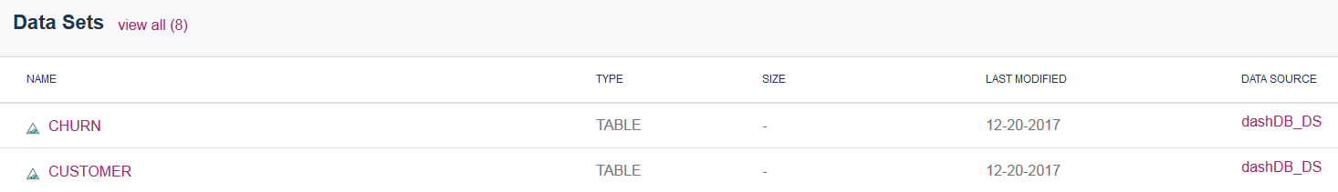

Part 3: Test Database Connection

- To test the connection, create a new Jupyter/Python notebook.

- Click on the data icon, then Remote tab and select the Insert to code option for one of the remote data sources. You can test both Spark and Pandas data frames.

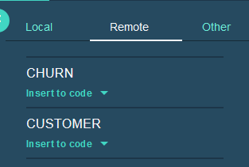

- Run the code and make sure data is displayed

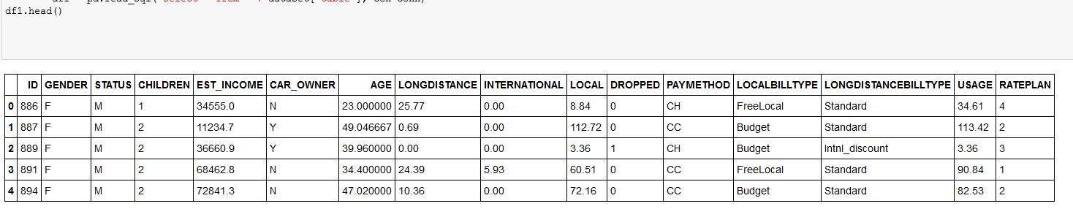

- If you wish, change the sample notebooks that use .csv to use a database data source.

Make sure to insert the correct data frame type.
- TelcoChurn notebook uses Spark data frames
- CreditCardDefault notebook uses Spark data frames

In addition to generating the code, you may need to change variable names.
Please check with the lab instructor if you need help with understanding how to modify the code.

Part 4: Configure HDFS and Hive connections in DSX
In this section we will define a non-secure connection to HDFS and Hive in DSX and access Hadoop data sources in a notebook.

Note: It’s possible to configure a secure connection (see official documentation). We are using a non-secure connection because we can quickly set it up in a demo environment.

These instructions for loading data to HDFS and Hive in HDP are specific to IBM Cloud Concierge and Fyre environments. If you’re working in a different environment, please check with the Hadoop administrator.

Please note that both, DSX Local and HDP must be in the same environment (Cloud Concierge or Fyre) when setting up the unsecure connection. Port 8020, which is used for unsecure connection, is not open, and the only way to get to the systems is via private IP.

- If the HDP instance was not provided, log it to Cloud Concierge (https://demo.ibmcloud.com) provision an HDP image.

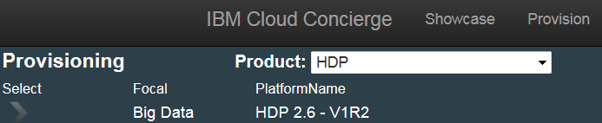

- Log in to HDP: Login to Ambari (HDP admin console): https://<hostname>:8080 with admin/IBMDem0s!

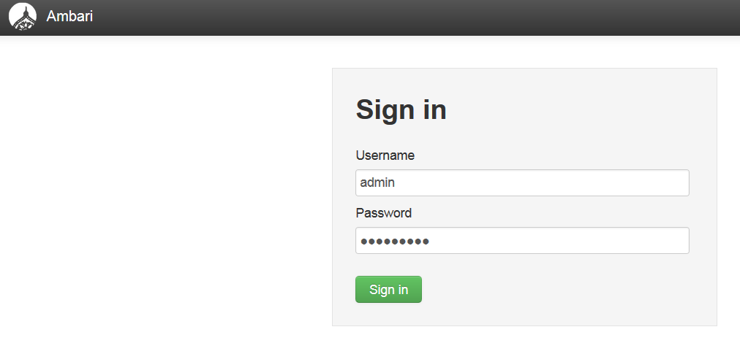

- Select Files View from the menu in the right corner.

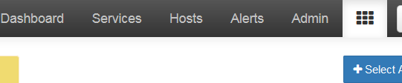

- In the Cloud Concierge environment, by default the admin user can only upload to /tmp directory. Navigate to the /tmp directory and upload any .csv file that we used in the previous labs (for example, files used for Telco Churn, Credit Card Default, or Data Science for Automotive use cases), for example, churn.csv and customer.csv that are used in the Telco Churn notebook.

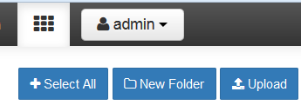

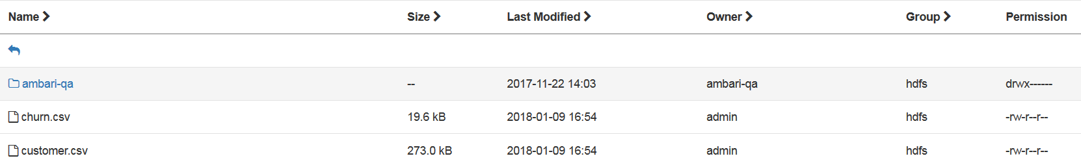

- If you would like to test connectivity to Hive, then complete the steps to create Hive tables.

If you are working as admin, you need to make sure that you have permissions to create folders and that /user/admin folder exists

Run these commands (from ssh) to allow admin to create folders in HDFS
- su hdfs
- hdfs dfs –chmod –R 777 /apps/hive/warehouse
- hdfs dfs –chmod 777 /user

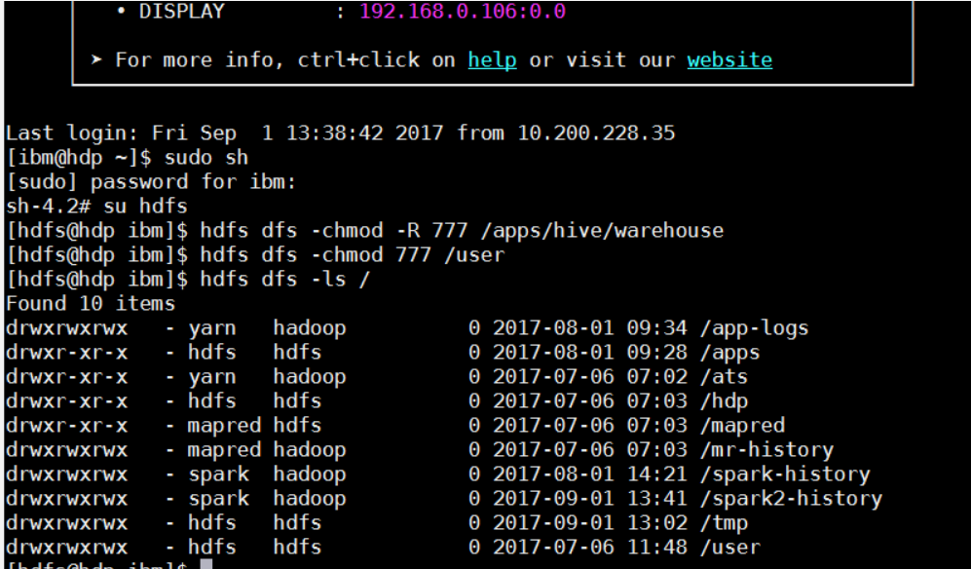

Navigate to the File view and create admin folder in /user

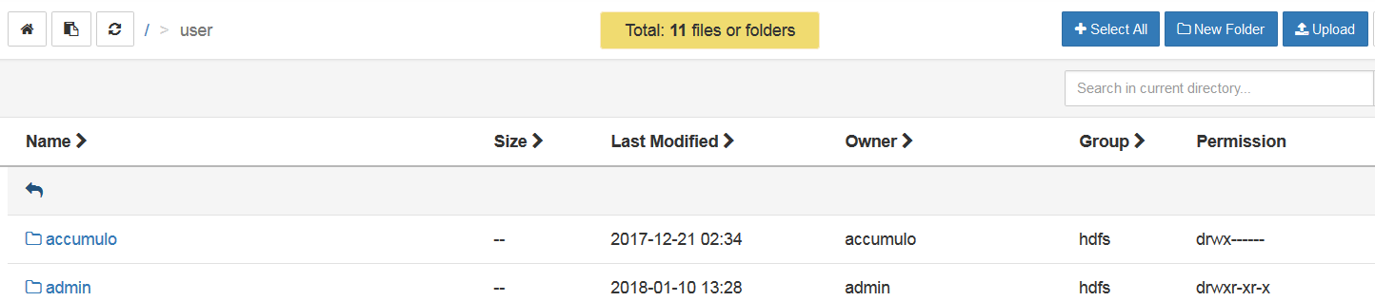

- Navigate to the File View (click on the ) and create admin folder in /user

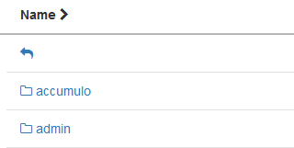

If you don’t complete this step, you’re likely to see this error: https://community.hortonworks.com/questions/80603/hdfs020-could-not-write-file-useradminhivejobshive.html

- Switch to Hive View 2.0

- Click on Tables. Click the + icon, then select Upload Table

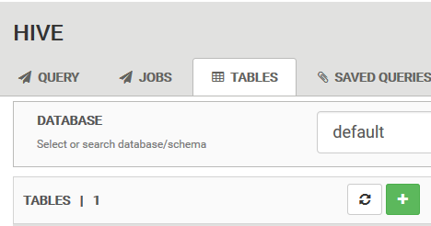



- Review/modify settings. If you are using one of the files from the sample notebooks, the first column is a header.

After selecting the file, verify that all data types are correct in the Preview. Click Create and don’t refresh the page (it’ll show status).

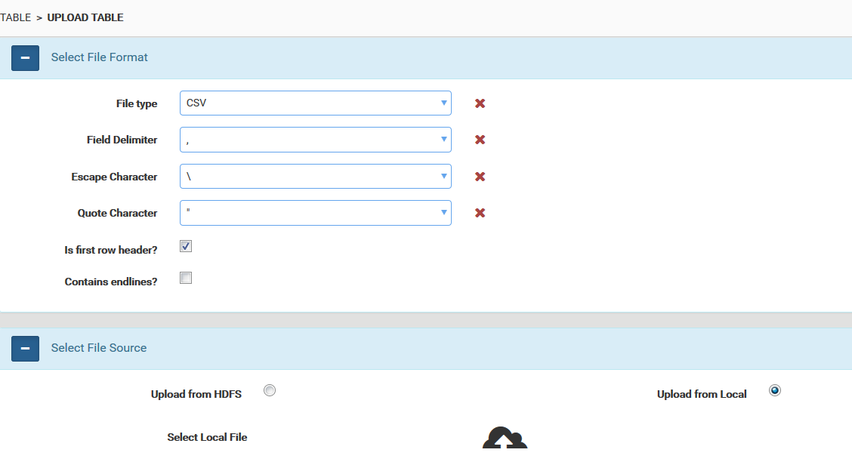

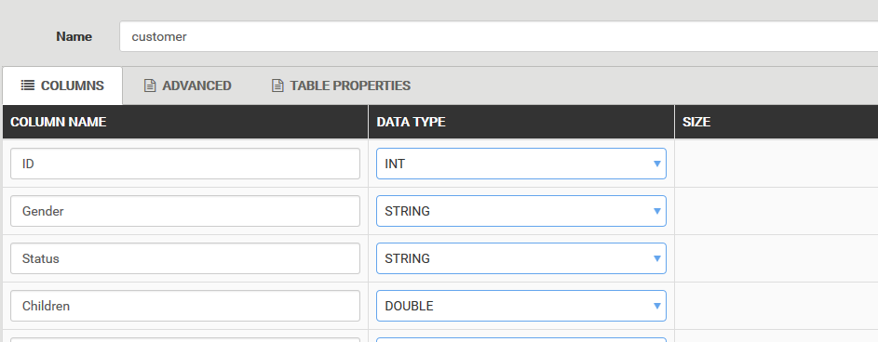

You have finished loading sample data into Hive.

- Now we are ready to define HDFS and Hive connections in DSX. Navigate to Project view for one of your projects (for example, DSX_Local_Workshop) and select Data Sources.

- Click add data source. Select HDFS - HDP from the dropdown. Replace IP addresses (IP address of your HDP cluster) in the other fields, but don’t change the ports.

Click Create.

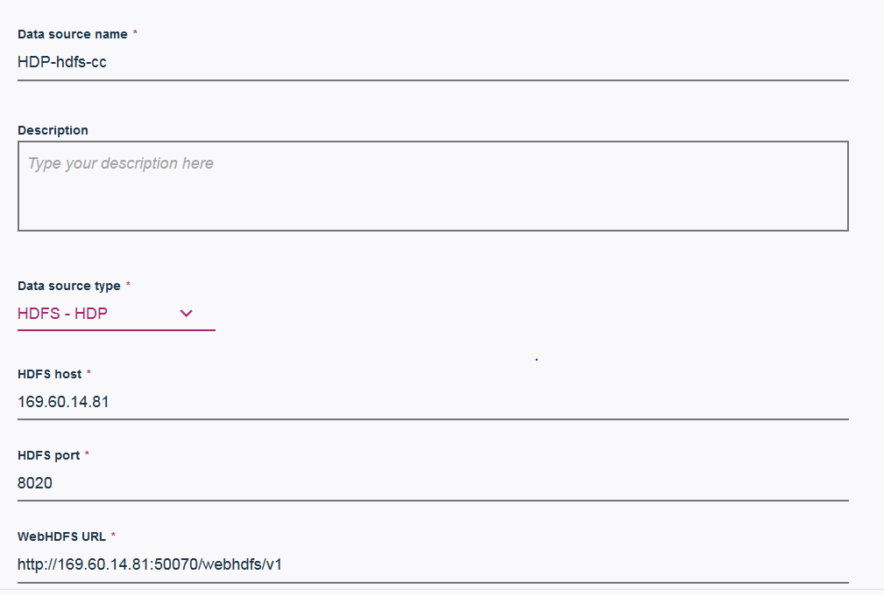

- Navigate back to the Data sources view in the project and click on the created data source.

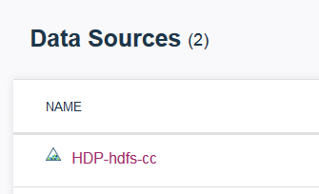

- Click add data set, then browse to the file you uploaded to HDFS. Select the file, click Open, then click Create.

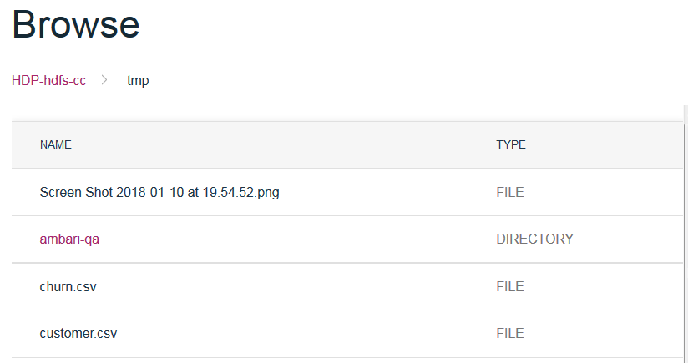

- Click add data source. Select Hive - HDP from the dropdown. Replace IP addresses (IP address of your HDP cluster) in the other fields, but don’t change the ports.

Click Create.

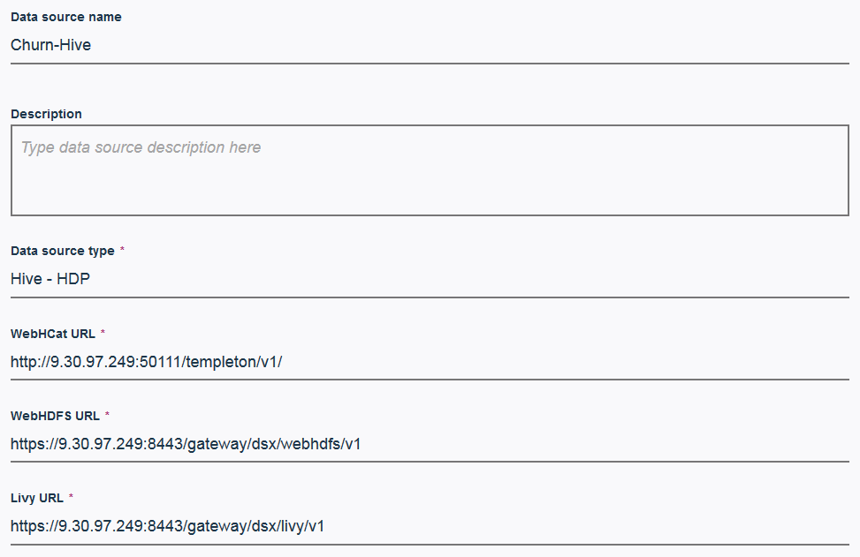

- Navigate back to the Data sources view in the project and click on the created data source.

- Click add data set, then browse to the file you uploaded to Hive. Select the file, click Open, then click Create.

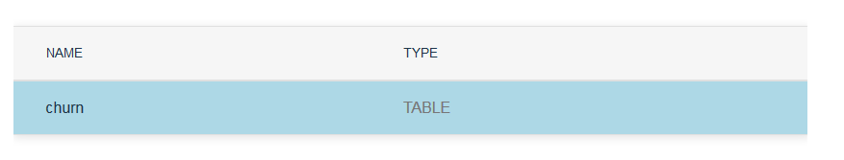

Part 5 : Test HDFS and Hive connection

- Create a new notebook and use code generation similar to database access code generation to test connectivity.

Hint: make sure to select a the Remote tab on data tab

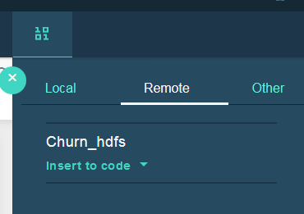

- If you loaded data sources for one of the sample notebooks, try modifying notebooks to use HDFS and Hive data sources.

